**Developments in Modern Battery Design and Charging**

Class: EECE 592-01

Prepared By: Dean Riccio

Submitted to Prof. R. Mauro

                                                                                     Date: 11.09.2020

**Table of Contents:**

**Name: Page #**

Introduction (I) ……………………………………………………………….1

The Creation of the Electronic Battery (II) …………………………………...1-5

Comparisons Between Different Battery Types (III) …………………………5-13

Research and Development in Battery Design and Charging (IV).…………13-17

Battery Charger Demonstration (V) …………………………………………17-23

Conclusion (VI) ……….……………………………………………………...24

References (VII) ……………………………………………………………...25

I. Introduction

An electric battery can be defined as a device that consists of one or multiple electrochemical cells with external connections. These external connections can be used for many different electronic devices, such as cell phones, laptops, and even electric cars. Batteries come in various shapes, sizes, and types as well. These include Alkaline batteries, Lithium-Ion batteries, Lithium Polymer batteries, and rechargeable/non-rechargeable batteries. Depending on the battery type being used for an electronic device or project will ultimately determine the voltage and current output of that given circuit. For example, many cell phones today such as the Apple iPhone and the Samsung Galaxy use a non-removable lithium-ion battery so that the device can essentially be recharged as many times as the user needs to. However, although the battery has been believed to have existed for over 2000 years by the Parthian Empire, the first rechargeable battery was not invented until 1859 by French Physicist Gaston Planté [3]. Improving upon the design of an electric battery ultimately is a process that takes lots of research and experimentation. In today's world scientists and researchers are developing batteries that are made specifically for electric cars and batteries that are cobalt free to reduce costs [4]. This paper will discuss the history and development of the battery, along with recent development. This paper will also be sought to discuss several different battery types and their applications, along with their characteristics to make comparisons. A battery charger will also be displayed showing how it operates and the components used to create it.

II. The creation of the electric battery

Although the first electric battery was invented and improved upon during the 19th century, a discovery was made while constructing a railway in 1936 near Baghdad. A worker uncovered a prehistoric battery, known as the Parthian battery. This battery was designed with a clay jar filled with a vinegar solution where an iron rod surrounded by the copper cylinder was inserted [3]. When the battery was filled with vinegar or an electrolytic solution, the jar would produce a voltage of 1.1 to 2 volts. The figure below shows a description of the battery and its surrounding elements.

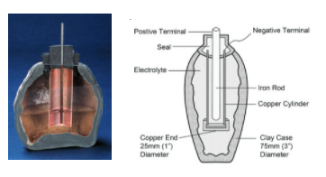

**Figure 1: A physical representation of the Parthian Battery, showing how an iron rod surround by an electrolytic liquid could produce electricity.**

Nevertheless, despite this discovery there are many scientists that do not accept the Parthian Battery as a source of energy seeing as this device could have been used for electroplating and Egyptians apparently used electroplated antimony well before the Parthian Battery was developed. This, however, was essentially the steppingstones used to design and articulate a battery that could produce a specific voltage and current rating like the ones used today. The first electric battery ever created was known as the voltaic pile, invented by Alessandro Volta in the year 1800 [7]. The idea originated from Luigi Galvani, an Italian scientist who ran an experiment where the legs of a frog would contract when forming a circuit with two different types of metal. Galvani then coined the term “animal electricity” although Volta disagreed and thought that his experiment proved that the electricity was a result of the two different types of metals in the circuit working together along with the frog legs between them [7]. Volta decided to ditch the idea of using frog legs and created a circuit that involved two different metals separated by a piece of cloth or cardboard soaked in brine which is an electrolyte. Volta was able to adjust the amount of electricity produced by stacking the battery with a pair of copper and zinc disks with an electrolytic layer between them. The figure below depicts the early prototype of the voltaic pile coined by Alessandro Volta.

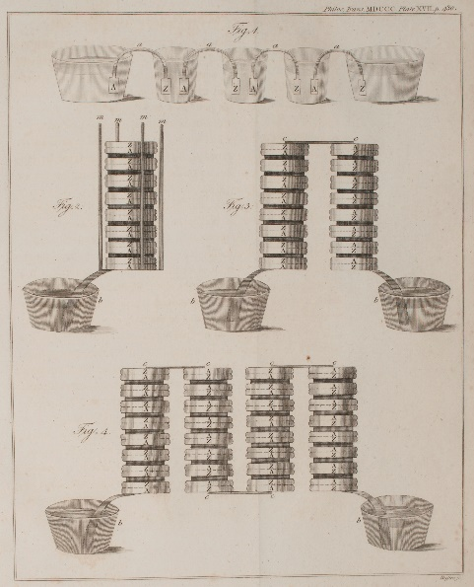

***Figure 2: A figure depicting an early voltaic pile with electricity in the excited state by the contact of conducting substances of various types.***

Volta used this early prototype of the voltaic pile to conduct several experiments using different types of metal. In these experiments Volta would measure the voltage across the voltaic pile along with its oxidation state to see which metal was best to use. Volta tested Zinc, Lead, Tin, Iron, Copper, and several other metals to compare the voltage ratings and oxidation state. Metals such as zinc had a low oxidation state of -0.76V with a voltage of 1.6V whereas metals such as Gold had a voltage rating of 2.4V with an oxidation of 1.83V. Through further studies and implementation Volta discovered that it was possible to have a continuous source of electricity from a battery as opposed to the sparks of electricity that would only last a fraction of a second [3]. By the year 1802, the first electric battery was produced for mass production by William Cruickshank using zinc and copper plates in a wooden box filled with an electrolytic solution. This newer designed compared to Voltas was advantageous in the fact that the liquid would not dry out and provided more energy [3]. The figure below shows the improved design that originated from Volta’s early vision.

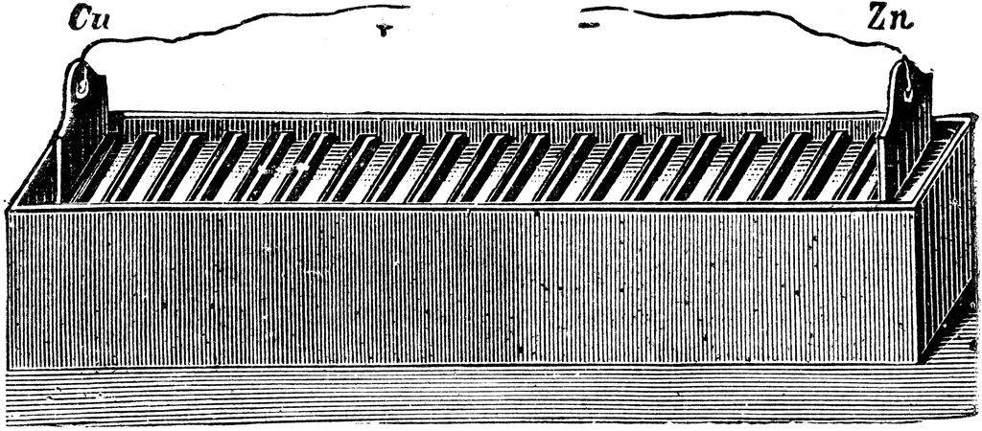

***Figure 3: A picture showing the wooden box using zinc and copper plates filled with an electrolytic solution that was sold to the public.***

The voltaic pile would be improved upon as the years followed, with John F. Daniell developing an improved battery in 1836 that was able to have steadier current ratings than the previous designs. It was not until 1859 however, when the first rechargeable battery was designed by Gaston Planté based on lead acid, which is a system that is still used today. Planté discovered that a lead acid battery could be charged by passing reverse current through it with the battery containing lead anodes and lead dioxide cathodes. These lead dioxide cathodes would be immersed in sulfuric acid and would produce current by exchanging electrons. The picture below shows some of Plantés first designs of lead acid batteries.

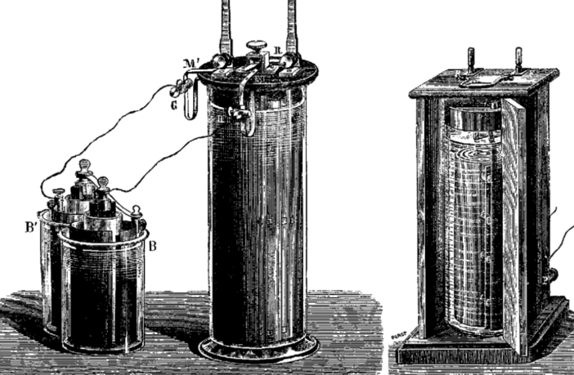

***Figure 4: Some of*** Plantés first designs of making a rechargeable battery.

By the end of the 19th century, Waldmar Junger would invent the nickel cadmium battery that would incorporate nickel as the cathode and cadmium as the anode. This, while being an improvement from previous designs, would be very expensive to make ultimately limiting the use of the battery for applications as a hole. Thomas Edison tried to improve the design by using iron instead of cadmium, but this resulted in low specific energy, power performance and high self-discharge [3]. This design would not be improved upon until 1932 when Schlecht and Ackermann achieved higher load currents by inventing the sintered pole plate. The nickel cadmium battery design was used for years after this discover up until the 1990s, when nickel metal hydride was a more environmentally friendly option and easier to dispose of.

III. Comparisons Between Different Battery Types

With today’s technological advancements there are plenty of options to choose in terms of a battery type to use for projects, systems, and devices. Ultimately, there are hundreds of distinct types, but the most used ones are Nickel Cadmium, Nickel-Metal Hydride, Lead Acid, Lithium Ion, and Lithium-Ion Polymer. Depending on the budget, safety, and purpose of the device being created by the engineering will distinguish what battery should be used. The size and shape of the device is also another important factor to consider when deciding a battery used to charge the device seeing as this will determine the exact dimensions of the casing needed to properly hold the battery. The figure below shows several different battery types that are used in cars, portable headsets, and electronic toys.

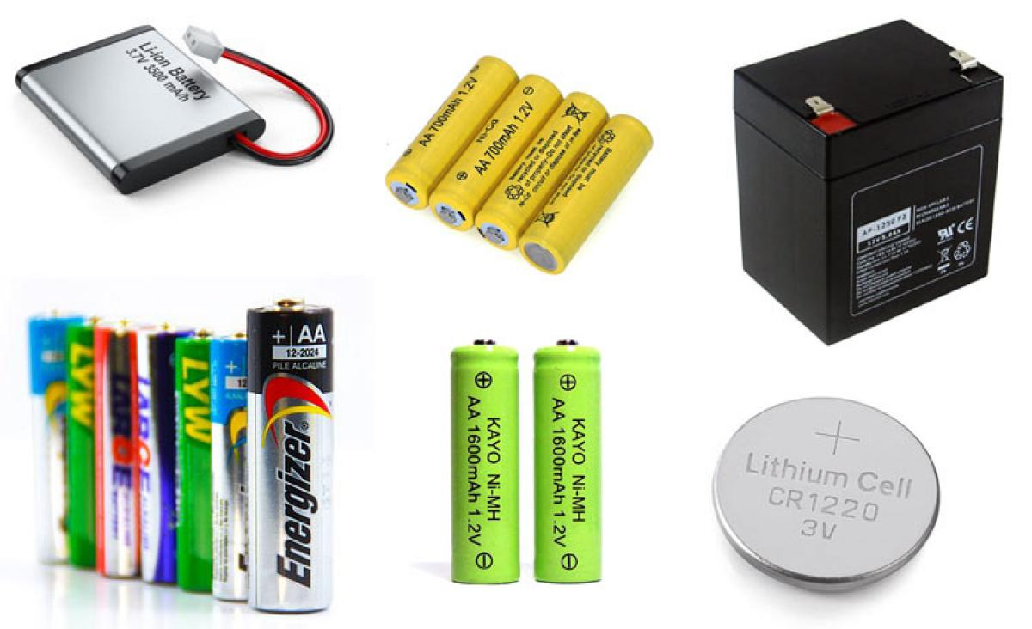

***Figure 4: A picture showing 6 different battery types that can be used for portable chargers, cars, and Bluetooth headsets.***

Nickel Cadmium batteries designed by Waldmar Junger is a battery type that is still used today due to its relatively low energy density [2]. Seeing as Nickel cadmium batteries are rechargeable, they can be used for many different applications such as two-way radios, professional cameras, and even biomedical equipment. Nickel-Metal Hydride batteries have a higher energy density compared to Nickel Cadmium and are a more environmentally approach but this comes at the cost of reducing the cycle life of the battery. The cycle life of a battery can be described as the number of times a battery can be charged to full capacity before it begins to deteriorate. The lower the life cycle of the battery means that the user will have to charge the battery will need to be recharged more frequently as it is used. Although the life cycle of a nickel metal hydride is lower compared to a nickel cadmium, it is a safer alternative to use for laptops and cell phones and contains less toxins. Lead acid are also another alternative as opposed to nickel metal hydride but are more expensive and used for larger power applications. Lead acid batteries are often used in UPS systems, emergency lighting and a lot of medical equipment [3]. When cost is not an issue lead acid battery are a better alternative to nickel cadmium and nickel metal hydride batteries [3]. Lithium-Ion batteries are one of the most recent battery types, invented by Professor John Goodenough in 1985 that offer a high-energy density and are very light in weight. These batteries types are still being researched and developed upon since they can be quite dangerous without a protection circuit and can catch on fire or explode if used improperly. Lithium-Ion batteries are often used in cellular devices along with notebook computers that do not require as much power or voltage to operate. Lithium polymer batteries operate similarly when compared to lithium-ion batteries, although they have lower energy density, have a much lower chance of explosion, take a shorter time to charge and does not age as fast [1]. These batteries are important to use when safety of the user operating the device does not experience any issues with the device exploding or catching on fire. Lithium-Ion polymer batteries are mainly used in mobile devices, such as cellphones and Bluetooth speakers and headsets. The table below lists the battery types used in today’s technical applications and how these characteristics differ from one another [3].

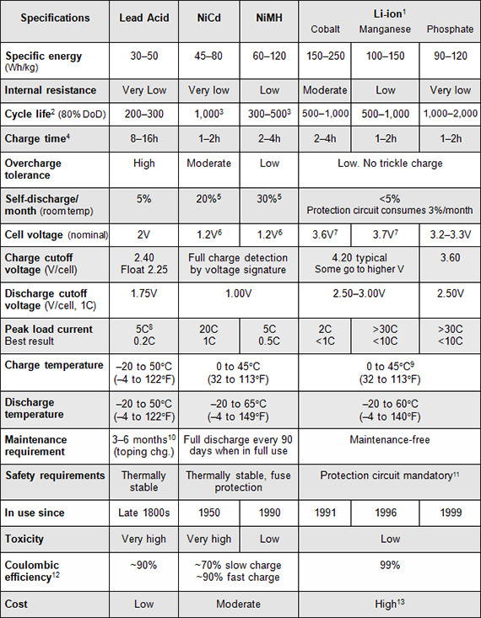

***Figure 5: A table discussing the specifications of several different battery types which can be used to determine which battery best suits to power a device.***

The table above discusses several different characteristics between the different battery types to categorize each battery and show the specifications regarding how they operate. Characteristics such as cost, cycle life, charge time, and charge temperature are all very important specifications when choosing or designing a battery. Looking at the table above shows how a lead acid battery takes 8 to 16 hours to charge while a phosphate lithium ion only takes 1 to two hours to fully charge [3]. Other properties such as the cycle life and maintenance requirements differ depending on the type seeing as lithium-ion batteries are maintenance free, while lead acid required to be discharged every 3-6 months and nickel cadmium and nickel metal hydride require to be fully discharged every 90 days when in use.

Lithium-ion batteries generally have a higher cycle life, a shorter charging time, and low toxicity but can be expensive depending on the amount of milli amp hours the battery can store [3]. The higher the milli amp hour, the more expensive and bulkier the lithium-ion battery becomes. Lithium-ion batteries also require a protection circuit for safety precautions since the overcharge tolerance is very low meaning that once the amount of current exceeds the batteries capacity, there is a high probability that the battery could either explode or catch on fire. Temperature is also another important factor when deciding which type of battery to use since certain devices and machine operate in cold or warmer temperatures. Both nickel cadmium and nickel metal hydride, and lithium-ion charge at a temperature between 0 and 45 degrees Celsius, while lead acid can charge at a temperature as low as negative 20 degrees Celsius.

Through the different specifications of each battery type it is important for the user to pick a battery charger that matches the traits and attributes of the desired battery in use. Without proper research or knowledge, a customer or client’s appreciation for said project or product is hindered because of carelessness and improper planning making the product ultimately useless to the user at hand. Properties such as the battery type, voltage ratings, maximum charging current, cost, and battery capacity all essentially determine the charger that will best suit the battery. To avoid these kinds of mistakes it is important to understand exactly how a battery charger works and what type of battery charger should be used. Despite the type of battery charger being used they inherently work the same in the fact that the charger sends an electric current through the batteries so that the cells inside the battery can hold onto the energy passing through from the charger [9]. The quality of battery chargers varies, but the more expensive a charger is, the higher the quality and addition of features such as over discharge voltage and current protection. A crude battery charger will use a constant voltage or current to apply to the batteries with no indication of when the charging of the battery is complete. The figure below represents a fast charging four cylindrical nickel-cadmium batteries that can charge four of them in 16 hours and one in five.

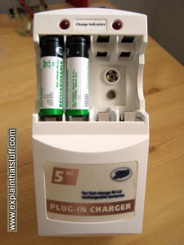

***Figure 6: A crude cheap battery charger that gives no indication when the nickel-cadmium batteries are done charging and lacks protection features.***

Battery chargers like the one in the figure mentioned above ultimately should be avoided, seeing as there is no sound or LED indicator to let the user know when the battery is done charging. The current running through the batteries from the charger is also continuous even when the batteries are fully charged. This process is known as discharging and is a worse alternative to undercharging since the excess energy can only be removed by heat and a built up of pressure inside the battery [9]. If a battery reaches its discharge limit it could rupture and leak dangerous chemical and gas that would be toxic for humans to ingest. Chargers of higher quality often use what is known as “trickle charge” where the current coming from the charger going into the battery is roughly 3 to 5 percent of the battery’s maximum current rate and often takes longer to charge. It is also important to keep in mind that batteries take longer to charge as they get closer to completion, meaning that the first 75% of the battery being charged will ultimately be faster than the last 25% of charging. This is because when a battery is charging, lithium ions move from one electrode to another to move the negative charges across each side. When the battery first starts charging the ions carrying a positive charge have a relatively easy time moving negative charges from one side of the battery to the other [9]. As more of the electrons are moved, there is less space for the positive ions to carry those charges and pack them onto one side of the battery. An example of a better battery charging system would be the battery manager, which is capable of recharging zinc carbon and alkaline batteries and has a display showing the voltage of each battery as it was being charged. The figure bellow shows the battery manager that was very popular to use in the 1990s [9].

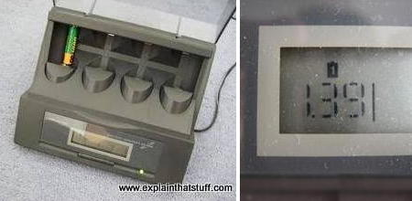

***Figure 7: A battery manager displaying the voltage across the single cell battery being charged by the system.***

Battery chargers and management systems have become much more sophisticated in the 2000s, with the use of printed circuit boards and microchip based electric circuits (integrated circuits) that allowed portable chargers for phones and other electronics the ability to fit in a user’s pocket. However, despite these advancements and options on recharging batteries, it is best to use the intended charger or one with similar characteristics to get the best performance out of a device. For example, nickel cadmium batteries respond best to rapid charging or slow trickle charging and are often used in flashlights.

Nickel metal hydride are a bit more expensive when compared to nickel cadmium batteries but can generally store more charge and can be fast charge, slow charged, or trickle charged. Fast charging allows higher current and takes up to several hours but has the risk of overheating the device, while slow charging taking around 12 to 16 hours using a lower amount of current [9]. Nickel metal hydride should not be charged with nickel cadmium chargers because if the nickel cadmium charger has a rapid charge feature it could discharge the nickel metal hydride batteries. An electric toothbrush is a typical example of using nickel cadmium or nickel metal hydride battery that has a charging stand that slow trickles the current into the toothbrush [9]. A good rule of thumb for nickel-based batteries is too “prime” them before use, meaning that the battery should be fully charged the first time before it is used in any devices or projects. Depending on the size of the nickel battery will determine the amount of current that the battery can store meaning that larger batteries will store more current but fundamentally take more time to charge. The picture below shows three batteries, all of which are different sizes and have different current carrying capabilities [9].

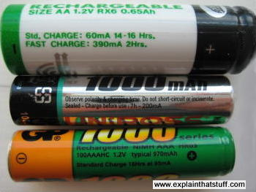

***Figure 8: A green nickel cadmium battery, a silver nickel metal hydride battery, and a green and orange nickel metal hydride battery all with different charging attributes.***

The figure above shows how nickel cadmium and nickel metal hydride batteries have different steady charge and fast charging capabilities. The green nickel cadmium battery has a steady charge rate of 60mA for 14 to 16 hours, while the fast charge rate is 390mA for 2 hours with the battery having a capacity of 650 milli amp hours. These ratings essentially give the user an idea as to how much current is needed to charge the battery up to a certain capacity, so with fast charging the user can expect up to 900mAh. However, these charging numbers are not 100 percent efficient, meaning that the battery does not absorb all the current coming from the charging source so approximations can be done depending on the given battery ratings. Other batteries like the lithium ion are similar in terms of their charging efficiency, although behave quite differently when compared to nickel cadmium or nickel metal hydride [9].

Lithium-ion batteries typically come with their own charging unit and become very unstable when above or below typical voltage values. When the battery voltage is too low, the device should cut out and when the voltage is too high the charger will cut out. Canon cameras have lithium-ion battery chargers to indicate when the battery voltage is too low or too high by cutting off the battery supply before the voltage dips and having the charger stop charging before the voltage exceeds the typical value [9]. Lead acid batteries are a bit different in terms of how they are charged, typically taking up to 16 hours but this is due to their high capacity and volume. Under charging or charging with an improper voltage can cause sulfation, which is the formation of hard lead sulfate crystals. Overcharging can cause corrosion which can permanently degrade the positive lead plate through oxidation. Either undercharging or overcharging will affect the battery life and overall performance of the lead acid battery. Lead acid batteries should be topped with distilled water, to keep the acid at its strongest to cover the plates entirely [9].

IV. Research and Development in Battery Design and Charging

Today’s generation offers many options to choose from in terms of battery type, shape, size and charging methods. As time has progressed from the 20th century to the 21st century many new discoveries and devices have been created to improve fundamental design of rechargeable batteries alongside their charging stations. Fast charging is a primary example of development that has occurred in the battery industry and originally started in 2012 mainly used in smart phone applications. USB Power Delivery is the official fast charging specification released in 2012 that can be used by any device that contains a USB port and the necessary circuitry and software to ensure these parameters [8]. This power delivery allows for charging speeds up to 100W of output power, but the amount of output power needed or used mainly depends on the devices. In terms of laptops and other high-powered devices, output power of 27W and above is suitable while 7.5W and 15W modes are best used for cellular devices. Smart phone chargers can essentially only outputs DC values, seeing as most smart phones operate at a nominal voltage of 5V and typically require 1A of current to charge. A phone charger that would be considered a fast charger would be twice the amount of current needed to charge the phone, with most fast chargers offering a charging rate of 2 to 2.5A of DC current. The main reason why phone chargers only uses DC is since USB only operates under DC power conditions. The picture below shows a fast-smart phone charger that I own, that I use to charge my iPhone 7 with its specified ratings.

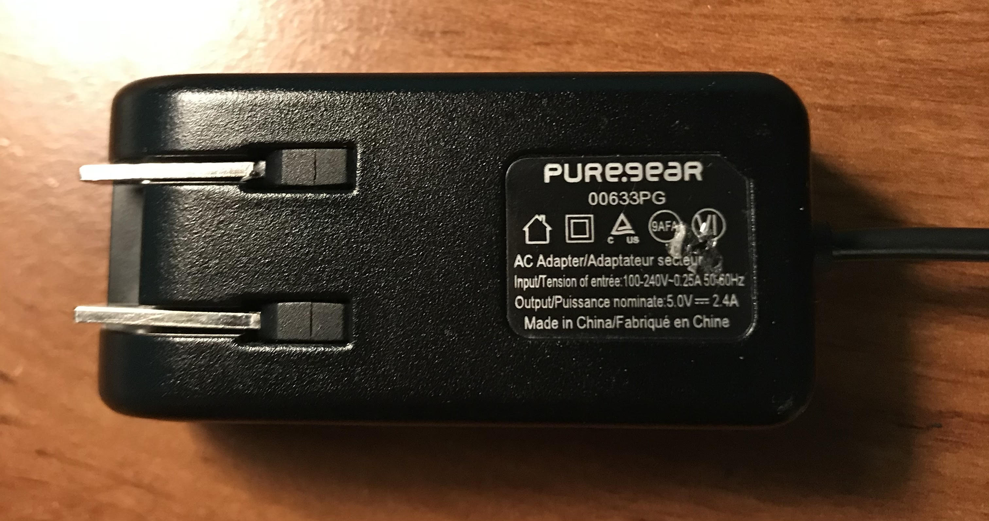

***Figure 9: A fast smartphone charger with a power rating of 12W, and a DC voltage of 5V and 2.4A.***

Qualcomm Quick Charge is another example of improving upon the foundation of rechargeable batteries. This fast charge feature is available with Qualcomm’s Snapdragon processors, and a wide variety of android phones have this feature enabled. These phones include the LG V40, Xiaomi Mi 9, Samsung Galaxy Note 9, and the HTC U12 plus [8]. Fast charge can be used with several different battery types, such as nickel cadmium and nickel metal hydride although batteries such as lead acid often take much longer to charge due to their higher capacity. Lithium ion and lithium polymer batteries can be used in a fast-charging system since they do not charge in a linear fashion. Charging these battery types can be broken up into two phases: the constant current and the constant voltage phase. During the constant current phase, the voltage steadily increases from approximately 2V to a peak of 4.2 as the battery charges drawing its highest peak current until the battery voltage reaches its maximum value. Once the battery reaches 4.2 volts, the voltage across the battery remains constant while the current decreases [8]. The figure below depicts a graph of the charge time, charge current, cell voltage, and the charge capacity of a 1C rating lithium-ion battery.

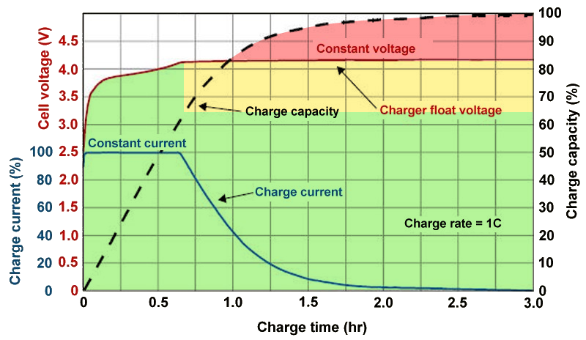

***Figure 10: A graph displaying the charge time of a lithium-ion battery with the voltage and current ratings over the charge time.***

Fast charging can charge batteries and devices faster due to the increase of an ample amount of current during the constant current phase. By adding more current into the first charging phase of the battery, the amount of time it takes for the battery to reach its peak voltage and remain constant at that voltage reduces. This however is only effective up to 80% capacity on the battery itself, with 80 to fully charged having no affect from the fast-charging implementation.

Wireless charger is another example of a new growing industry in today’s world of battery design and charging. Wireless charging is an upcoming industry that while used in many smartphones, is also being developed into healthcare, automotive and manufacturing industries. According to David Green, a research manager with HIS Markit, there are currently three types of wireless charging [5]. These types include, charging pads that use tightly coupled electromagnetic charging, charging bowls or surface type charges, and uncoupled radio frequency wireless chargers that allow trickle charging from several distances of feet. A wireless charger is essentially composed of a magnetic loop antenna that creates a magnetic field, which then produces current in one or multiple receiver antennas. The amount of induced current from the resulting magnetic field can be increased if the capacitance added has the loops resonate at the same frequency. The size of the coil can also determine the distance that the power can transfer in the circuit, meaning that larger coils often result in a greater distance that the current can travel. Smartphone chargers, however, are limited to how far the power can travel due to the copper coils used in the charger only being a few inches in diameter. Larger coils can essentially be used in automobiles, wind turbines, and robotics allowing for a greater power distribution and current flow without having to use wires or plug-in cables to charge the devices [5]. The figure below depicts what is inside a typical wireless charger used for smart phones and other small portable devices.

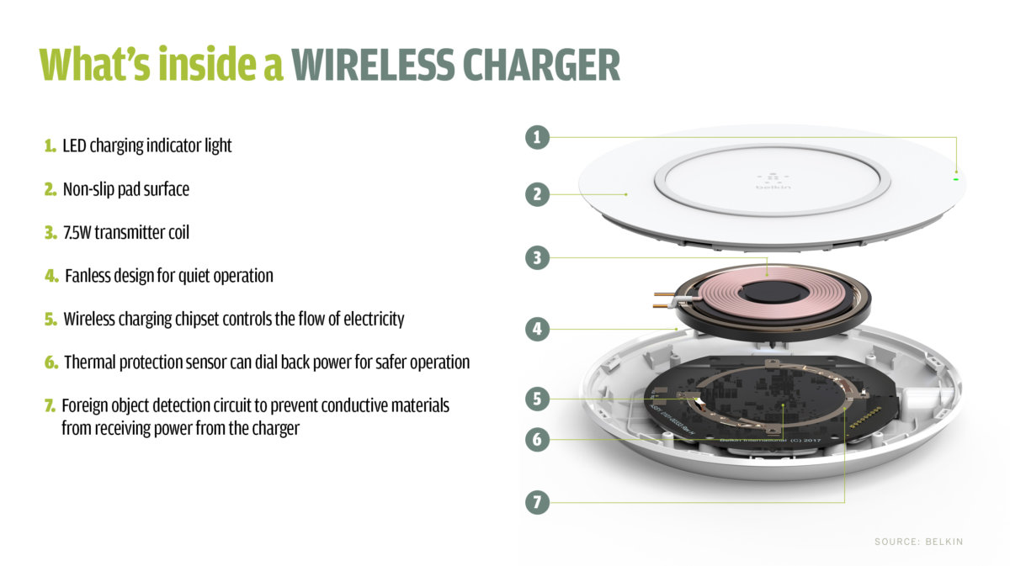

***Figure 11: A cross section of what is inside a typical wireless charger used for smartphones.***

Fast charging and wireless charging are just two examples of improvements upon battery design and charging, and there are many companies researching and developing on the original concept behind rechargeable batteries. One example of this can be seen by NAWA Technologies, which has designed and patented the Ultra-Fast Carbon Electrode, a design that would provide great improvements and attributes to the battery industry. The battery uses a vertically aligned carbon nanotube designed to boost battery power and would increase the energy storage of a battery by triple the amount and the lifecycle five times. These batteries would mainly be used for electric vehicles, with the charging time cut to 5 minutes to reach 80% capacity and could potentially be in production as soon as 2023 [4]. StoreDot is another example of a company currently researching and experimenting with phone chargers that have the potential to recharge in 60 seconds. These types of battery chargers are made by using biological semiconductors made from organic compounds called peptides which are short chains of amino acids or often referred as the building blocks of protein. Batteries that are safe from explosion, are another type of battery being researched and tested seeing as batteries such as lithium ion are very dangerous and can result in catching on fire, as seen with the Samsung Galaxy Note 7 a few years ago. Mike Zimmerman, a researcher at Tufts University in Massachusetts developed a battery that has double the capacity of a typical lithium ion and without the dangers that come along when using these types of batteries [4]. This battery can be pierced, shredded, and exposed to heat seeing as it is composed of a nonflammable material. Although it is not exactly ready to be launched in the market, nevertheless, safer alternatives are being created and researched as opposed to the typical lithium-ion battery that has existed since the 1990s. Stanford University is currently researching lithium metal batteries as a potential candidate to take over the lithium ion industry. By replacing the graphite anode with lithium metal, this allows lithium metal batteries to store a significant amount of more energy [6]. This replacement was done by using fluorine to attract electrons to create a new molecule that allows the lithium metal anode to function efficiently in the electrolyte. Through some experimentation it was determined that the battery retained 90 percent of its charge after 420 cycles of charging and discharging.

V. Battery Charger Demonstration

To truly understand the concepts discussed in class along with batteries and chargers in general I decided it was best to break down an old battery charger I have and try to understand its composition. The charger I took apart and put back together for this demonstration is a Nickel Cadmium/Nickel Metal Hydride 9-volt battery charger that is used for 9-volt rechargeable batteries only. Looking at the charger from a first glance shows that it is very simplistic in terms of its presentation and purpose. The figure below shows the front and back side of the Nickel Cadmium/Nickel Metal Hydride Charger.

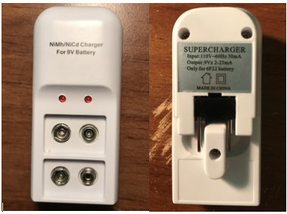

***Figure 11: A picture of the front and back side of the Ni-MH/Ni-CD 9V battery charger with its specified input and output ratings.***

The figure above shows that two nine-volt batteries can be inserted into the charger and charged at the same time, provided the two-pronged plug is always plugged into an outlet. When a battery is plugged the corresponding red LED turns on letting the user know that the battery is consuming power and charging. The charger specifies that the input voltage is 110V with a frequency of 60Hz and draws 30mA of current. This input voltage is from the wall seeing as America typically outputs 120 to 130 Vrms AC voltage. The output of the charger shows purely DC levels, seeing as the 9V battery being charged only contains DC values of voltage and current. To understand how this charger worked, I first unscrewed the three screws on the back to get a look inside of what components were used to make the charger. The figure below shows the inside of the charger after the screws were removed from the casing.

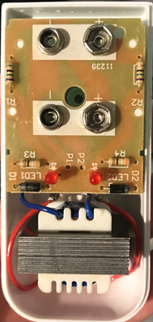

***Figure 11: A picture of the different components used to create the Ni-MH/Ni-Cd battery charger.***

Looking at the components inside the board allowed me to determine the resistor values, LEDs, didoes, and transformer used to create the circuit. Using a resistor color code chart, I was able to determine that R1 and R2 were 75ohm resistors and R3 and R4 were 370ohm resistors. The didoes used D1 and D2 were germanium 1N4002 didoes like the ones given in class for the different lab experiments. The red LEDS used to show the user when the battery is charging appeared to be standard and was presumed to have a voltage of 1-1.2 volts. I then turned over the PCB to see exactly how the traces were laid out to understand how the components were placed. Starting from the transformer, I followed the traces while keeping the polarity of the 9-volt DC battery and red LEDs in mind to ensure that the current was flowing in the right direction as I interpreted the traces. After carefully looking at the PCB traces for some time I began creating a rough layout of the schematic in Pspice, seeing as I already knew the expected output voltage and current given from the charger itself. The transformer was unfortunately not labeled with a value, so I soldered off the joints connecting the two-prong output on the red wires and the two blue wires from the PCB connection. I then soldered two jumper wires onto the two prong output joints and connected the wires to a breadboard and put the red transformer wires in the same row as the jumper wires. I measured the voltage across my input of the outlet from the two jumper wires using my multimeter and obtained a Vrms values of 130V and multiplied that value by the square root of 2 to get 183V seeing as the input coming from the wall outlet is a sine wave. I then measured the voltage across the transformer by connecting my multimeter probes to the blue wires on the transformer and obtained a value of 17Vrms, or 24V. Once the voltage was determined I ran several tests in Pspcie to see if I could get the proper input and output values. I realized that the circuit made for the charger was a clipper circuit, which is one of the circuits made in the lab experiment using the parts given along with a DC wall wart. Through some trial and error, I was able to obtain the proper values by carefully reading the PCB traces along with making sure I was using the correct components to successfully duplicate the circuit. The figure below shows the PCB traces labeled with values and arrows to dictate the current flow in the circuit.

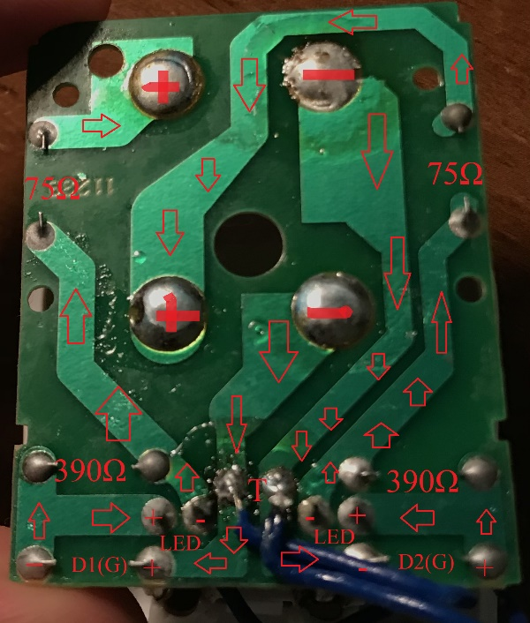

***Figure 12: The PCB along with labeling to show the current flow and layout of the circuit.***

The circuit essentially operates by using a 24V AC transformer and having a 1N4002 Germanium diode in series with a 390-ohm resistor, a Ga As LED, a 75-ohm resistor, and a 9V battery used to consume current and store charge. When the charger is plugged in without any 9-volt batteries there is an open circuit at the output causing the red LED to be off with not enough current to turn the LED on. Once the 9-volt battery is plugged in it acts as a short allowing current to flow through the anode of the LED and turn it on letting the user know that the battery is charging. The charger also uses the same circuit layout twice and places them in parallel so that multiple batteries can be charged at once with the same voltage and current outputs. The circuit outputs anywhere between 2 to 25 mA of current, and this is because the diode clipper circuit clips the positive part of the AC sine wave, leaving only the upper half at the output. Since I did not have any LEDs in my library or components in Pspcie, I edited the D1N914 model to have a voltage of 1.1V causing a 1.1voltage drop by putting in the value VJ=1.1 in the model editor. The figure below represents the schematic representation of the circuit built for the charger.

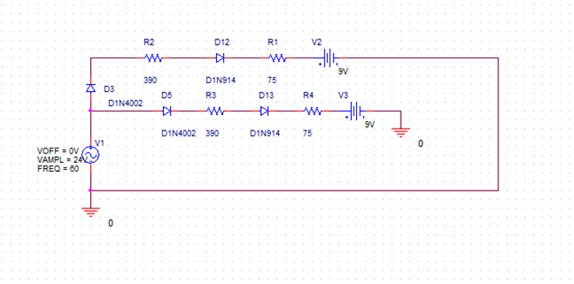

***Figure 13: The schematic representation of the charging circuit used to recharge a 9V battery.***

The figures below show the Pspcie results from the simulation of figure 13, thus matching the values of the input and output labeled on the back of the charger.

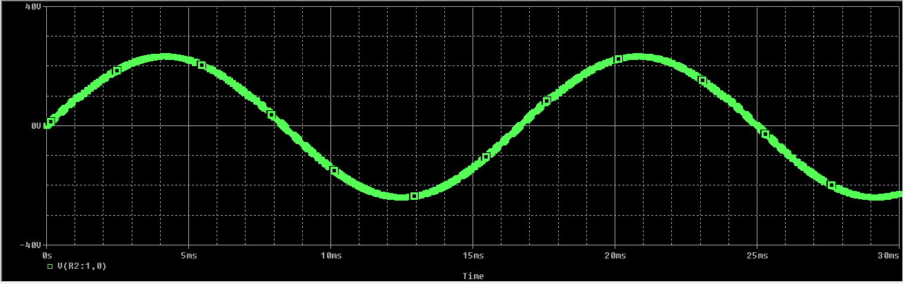

(a)

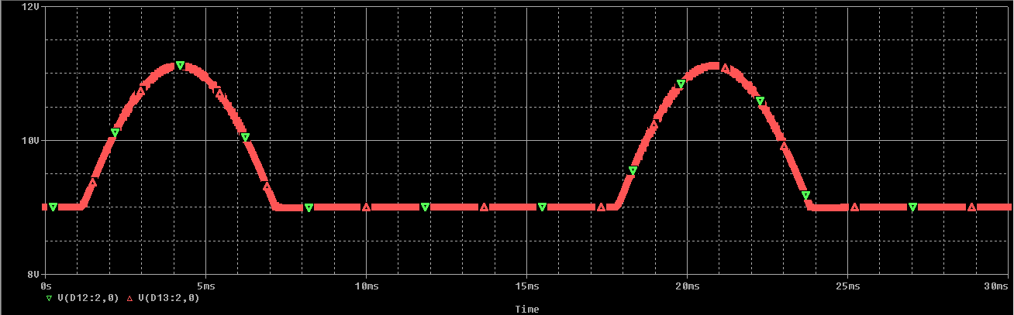

(b)

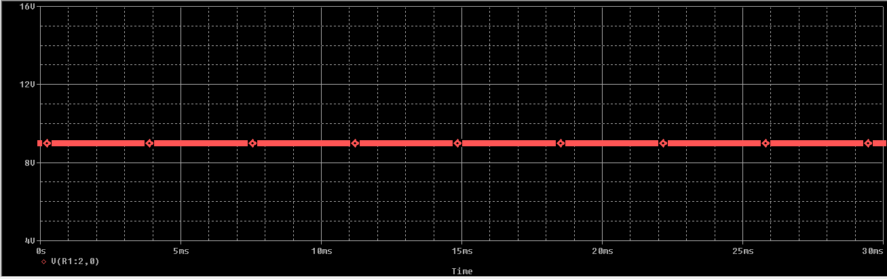

(c)

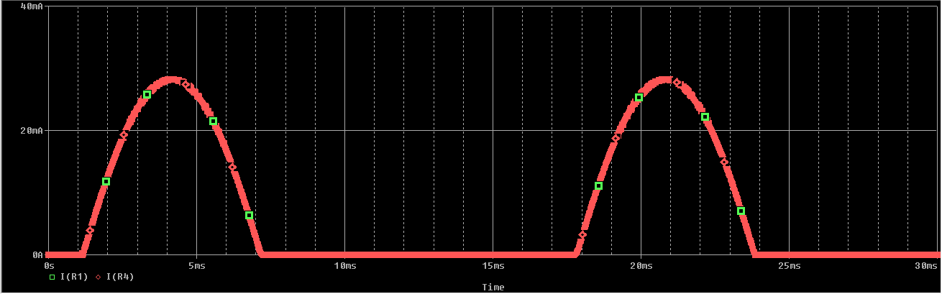

(d)

***Figure 14: (a)The voltage input sine wave of the clipper circuit. (b)The output voltage coming from the clipper circuit. (c) The output voltage coming from the 9V battery. (d) The output current ranging from 2 to 25 mA.***

The figures above from the Pspice simulation show that the circuit was built correctly, since the output voltage and current were clipped from the original sine wave input with an output current rating of anywhere between 2 to 25 mA. The voltage at the output of the circuit is 9V which is expected since the charger is used only to charge 9V rechargeable batteries. Although the current is 0mA at certain points of the clipped sine graph, this only occurs for a few milli seconds which is a very small amount of time compared to when the battery is charging. The battery used to for the battery charger was a Tens Cell 9V Nickel Metal Hydride rechargeable battery with a current rating of 250mAh. To calculate the charge rate of the battery, by using the formula Charge time = Battery mAh Capacity/mA charge rate. The battery charger outputs anywhere between 2 to 25mA of current, meaning that the battery could take approximately 10 to 15 hours to charge if its fully discharged.

VI. Conclusion

Modern battery design has truly paved the future of technological devices, with fast and wireless charging along with new developments being researched allowing for better medical equipment, transportation, and devices used for entertainment. Alessandro Volta along with John F. Daniel and Gaston Planté made amazing breakthroughs with battery technology, allowing batteries to be sold to a public market and give people the option to use a rechargeable or non-rechargeable battery. When choosing a battery for a project or device it is important to understand the batteries characteristics, in terms of its discharge rate, charging capacity, and size and shape. Lithium Ion and Lithium polymer batteries paved the way for future battery technology, although they are still being improved upon since they can be quite dangerous if used incorrectly. The battery charger that I took apart and built the circuit in Pspice ultimately showed me that a clipper circuit can be used to create a plug-in charger, which is one of the concepts covered in the first lab experiment. Figuring out how the charger was built gave me a better understanding of clipper circuits, along with the parts needed to create a battery charger. This project allowed me to learn a lot more knowledge about the different battery types and their specifications, along with future battery types and chargers in development.

VII. References

* 1. “All About Power Banks - Lithium-Ion v/s Lithium Polymer Battery.” *Rediff*, 30 Oct. 2015, www.rediff.com/gadget/report/all-about-power-banks---lithium-ion-vs-lithium-polymer-/20150526.htm.
  2. “BU-107: Comparison Table of Secondary Batteries.” *Secondary (Rechargeable) Batteries – Battery University*, 2011, batteryuniversity.com/learn/article/secondary_batteries.
  3. “BU-101: When Was the Battery Invented?” *Information on the Invention of the Battery - Battery University*, 2019, batteryuniversity.com/learn/article/when_was_the_battery_invented.
  4. Hall, Chris. “Future Batteries, Coming Soon: Charge in Seconds, Last Months and Power over the Air.” *Pocket*, 6 Oct. 2020, www.pocket-lint.com/gadgets/news/130380-future-batteries-coming-soon-charge-in-seconds-last-months-and-power-over-the-air.
  5. Mearian, Lucas. “Wireless Charging Explained: What Is It and How Does It Work?” *Computerworld*, Computerworld, 28 Mar. 2018, www.computerworld.com/article/3235176/wireless-charging-explained-what-is-it-and-how-does-it-work.html.
  6. Shwartz, Mark. “New Electrolyte Design May Lead to Better Batteries for Electric Vehicles.” *Stanford News*, 22 June 2020, news.stanford.edu/2020/06/22/new-electrolyte-design-may-lead-better-batteries-electric-vehicles/.
  7. “The Voltaic Pile.” *Distinctive Collections Spotlights* libraries.mit.edu/collections/vail-collection/topics/electricity/the-voltaic-pile/.
  8. Triggs, Robert. “How Fast Charging Really Works.” *Android Authority*, 8 Aug. 2019, www.androidauthority.com/fast-charging-explained-889780/.
  9. Woodford, Chris. “How Do Battery Chargers Work?” *Explain That Stuff*, 21 Mar. 2020, www.explainthatstuff.com/how-battery-chargers-work.html.